Synopsis

(PCA20P03L: Project Work)

# On

“College ERP System”

# By:

Students Name: Mr. Jatin Sharma

Reg. No.: RA2132241030008

Branch and Year: MCA- 4th Sem/ 2nd Year

Under the Guidance of:

Faculty name: Dr. Rajeev Sharma

Project Coordinator: Dr. Rupak Sharma



Department of computer applications

SRM INSTITUTE OF SCIENCE & TECHNOLOGY, NCR CAMPUS, MODINAGAR

# GHAZIABAD, (U.P.)

**TABLE OF CONTENTS**

|  |  |  |
| --- | --- | --- |
| **S.No** | **Contents** | **Page No** |
| 1. | Introduction of Project | 3-4 |
| 2. | Project plan and problem definition | 5-8 |
| 3. | Software Requirement Specification | 9-12 |
| 4. | Technical details | 13 |
| 5. | Activity chart, Class Diagram, ER Diagram | 14-16 |
| 6. | References | 17 |

**Introduction of Project**

The objective of College Information Management System is to allow the administrator of any organization the ability to edit and find out the personal details of a student and allows the student to keep up to date his profile. It'll also facilitate keeping all the records of students, such as their id, name, mailing address, phone number, DOB etc. So all the information about a student will be available in a few seconds. Overall, it'll make Student Information an easier job for the administrator and the student of any organization.

The main purpose of this project is to illustrate the requirements of the project College Information Management System and is intended to help any organization to maintain and manage personal data. It is a comprehensive project developed from the ground up to fulfill the needs of colleges as they guide their students. This integrated information management system connects daily operations in the college environment ranging from Attendance management to communicational means among students and teachers. This reduces data error and ensures that information is always up-to-date throughout the college. It provides a single source of data repository for streamlining our processes and for all reporting purposes. It has a simple user interface and is intuitive. This insures that the users spend less time in learning the system and hence, increase their productivity. Efficient security features provide data privacy and hence, increase their productivity.

As we know that, a college consists of different departments, such as course departments, fees management, library, event management etc. Nowadays applications and uses of information technologies is increased as compared to before, each of these individual departments has its own computer system to do their own functionalities. By having one main system they can interact with each other from their respected system by having valid user id and password.

Time schedule for completion of the project work

The Project schedule activities will consist of following:

1. Selecting The Project Title
2. System Requirement Collection
3. System Design
4. Acquiring the required resources
5. Coding
6. Testing of the Application
7. Deployment

**Project plan and problem definition**

Inception

Inception is a process of establishing a basic understanding of the problem and the nature of the solution. This includes the need for this software, identification of stakeholders and defining multiple viewpoints.

What is the purpose of this project?

There is currently an ERP system in our college. But, not everyone is happy with the system. While it is a step towards automating the college activities, it comes with its own set of problems. This project is designed to implement a college ERP system to eradicate some of these problems and add some features of our own that would add value to system.

Why do we need ERP?

Nowadays, in schools and colleges, it is very difficult to manage each and everything manually. Supervising and maintaining the whole database of a school or college can be time-consuming and challenging especially if it’s done on a regular basis. So, we need to handle and manage everything smartly.

To solve this problem ERP (Enterprise Resource Planning) is used. ERP software makes it easy to track the progress of every department of school and automate different functions. With ERP every- thing can be seen on a single dashboard. The administrator can manage the college from anywhere. The possibilities of maintaining the whole database of a college with ERP software are endless.

Some of the prominent roles of ERP are:

• Manages the office and automates different functions.

• Helps in long-term management and planning of all departments of college.

• Eliminates the need for having multiple management software for each

department.

• Daily activities like attendance can be digitalized and automated.

• Leave module for teachers can be automated.

Identification of stakeholders

Enterprise Resource planning implementation is a difficult and complex decision where it involves people issues more than technological issues. Identification of stakeholders is a key step during the process of ERP implementation, because if done improperly, it will lead to failure of the implementation project. The stakeholders are listed below:

Teachers

Teachers are the key stakeholders of the college ERP. Because they are the one who manage, edit, update the contents of the database of students such as attendance, internal marks, CGPA etc...

It also helps them to assign their class to other teachers when they are on leave. This makes it easier to identify who among them are free to take the class at that time. So this software helps them reduce their overhead and make their tasks easier and simple.

Students

Students are end users of ERP software. The attendance, internals marks uploaded by the teachers is viewed by students. It helps them track their attendance status. It also helps them to communicate with teachers and their classmates. So students make up another set of stakeholders of this software.

Administrator

College administrator is responsible for maintaining the database of the college. They will have the privilege to modify the database i.e., to add/remove students/teachers/staff, update information regarding each of these.

Viewpoints

For a teacher, this software must be easy to use. It should be easy to find different modules like attendance, leave module, internals marks, result etc...Teachers are the one who updates the contents of the database, so it should be update save modify it.

Students viewpoint

A student can only view the information about himself, other than that everything will be hidden from them. They will not have the option to edit anything. So the graphical user interface must be good. They expect it to be functional.

Administrator’s viewpoint

Administrator will have the privilege to view all the information about the college. They will have the option to track goals like, Average marks of all the students in a subject, Average attendance of all the students of a class etc.

What do you expect from the module the lets you enter the marks of the students?

There will be another section to enter the CIE of all the students. The internals will be for 20 marks and when the faculty enters it into the ERP, it must automatically convert it into 10 marks. Generally, there will be 5 events. There will be 3 internals, followed by two events such as quiz, project. If the student scores below 50% of the allocated marks in the subject, then there must be a warning message sent to the student to score more marks in the upcoming internals.

At the end of all the events if the student could not mark the 50 mark, then there will be a make-up test conducted by the faculty so that the student would be having another chance to come up to the mark of 50%. These make-up test marks must be altered with the minimum marks of the CIE scored. And the final CIE marks should be displayed and be stated that the student is eligible or not eligible to take up the Semester End Examination. If the student is not able to take up the CIE due to personal reasons or if he is representing the college in any form of the activity, then it must be brought into the notice of the lecturer and the leave can be availed. If the student is ill, then the medical certificate must be attested, and a letter must be sent to the HOD to take up re-test. After the faculty enters the CIE there must be an option to save the CIE marks. When the CIE marks are saved then the students will not be able to see the marks in their marks. They can view their CIE only when the marks are locked by the faculty. If the faculty locks the CIE, then there would not be any chance to change the CIE. The CIE must be locked after confirming the marks with the students only.

As a student, what are some problems you are facing with the current ERP system?

The ERP status was not updated regularly, and they could not track their attendance status as the app would crash. The GUI that is used in the interface is not up to the mark. It is difficult to keep the track of the attendance and the CIE. It would be easy if the attendance would be shown in a calendar like format so that it would be convenient and can also keep a track of the status of the attendance. There should also be forums where the teacher and the students are active. This will help the students in many ways such as studies, assignments, projects and so on. There should be interaction with the student-student and student-teacher so that the students can clear their doubts with any teacher as well as any student at any point of time. The forum will also help the students in conveying the information to all the students at a faster rate.

For the students who were in supplementary batch, they could not attend the first few weeks of class as they had exams. But, in the ERP they were marked as absent which made their attendance drastically low.

When the students are into college activities such as LCC sessions, IEEE sessions, representing our college in sports or any other activities then students are marked absent. There must be another way to handle these problems so that there will be justice for the students for their hard work.

**Software Requirement Specification**

Purpose

The purpose of this project is to develop a College Management System that helps the teachers and students in easier management of College activities such as attendance, marks.

Overall Description

Product Perspective

This project is modeled based on the current ERP system in the college. Students and teachers face several problems while using the system. Therefore, we wanted to build a system that has lesser number of features than the current system but, has more functionality.

Product Features

• Each teacher will be able to enter attendance and marks for their respective students.

• Each student will be able to view the attendance status for their respective courses.

• The teachers will be able to apply for various types of leave directly through the system.

• The students will be able to Communicate and provide feedback to their teachers.

• The students will have access to a forum page where they are communicate will each

other.

User Classes and Characteristics

There are several types of end users for the college ERP system. They are broadly divided as Students, Staff and the Administrator. Each of these classes has their own set of features.

The student should have the following features:

• View the Attendance status of the courses to which they are enrolled.

• View the Marks of the courses to which they are enrolled.

• View the notification from the college administrator.

• Communicate or give feedback to their respective teachers.

• Communicate with other students of the same university.

The staff should have the following features:

• Access to the information of all students that attend their courses.

• Add and edit the Attendance status of those students.

• Add and edit the exam marks of those students.

• Avail the different types of leave.

The administrator should have the following features:

• Add and update students, teachers and courses.

• Assign teachers and students to courses.

System features

Expected requirement: Student and staff information

Description and priority Information regarding students, teachers and courses are stored in the database. Every user can view only certain information based on their user class. For example, a teacher can view student and course information that they are handling. This feature is of high priority as the information must be viewed by only the authorized users.

Functional requirements

• Each user shall be able to view information in the database based on their user

class.

• The administrator shall be able to view all the information in the database.

Normal requirement: Attendance and marks entry

Description and priority Attendance and marks entry is the main feature of the College ERP system. Hence, the priority is high. Teachers update the attendance and marks of the students who are part of her class. Students can view their respective Attendance and marks of the courses they have taken.

Functional requirements

Teachers shall be able to view, update and edit the attendance and marks of the students, part of their class.

• Teacher shall be able to take extra classes, switch classes with other teachers.

Exciting requirement: Communication among students and teachers

Description and priority Students and teacher will be able to communicate with each other directly using the ERP system. Students may give their queries and feedback to a teacher and they may respond accordingly.

Functional requirements

• Students shall be able to communicate with their teachers by sends personal messages.

• Students shall be able to communicate with other students through a forum section.

External Interface Requirements

User Interfaces

The User interface is made using Bootstrap. Firstly, there will be a simple login page separate for students and teachers. Each student and teacher will have a unique interface. There will be a fixed sidebar with links to all the modules.

Hardware Interfaces

Since neither the mobile application nor the web portal have any designated hardware, it does not have any direct hardware interfaces. Any browser can be used to access the web-app.

Software Interfaces

The following is a list of software used in making of the project.

Operating System: We have chosen Windows operating system for its best support and user- friendliness.

Django: We have chosen to use Django for the back-end of the website as Django is a simple python framework and is suitable for beginners.

• Database: We are using SQLite database, which comes as default with Django.

Communications Interfaces.

Non-functional requirements

Safety requirements

If there is extensive damage to a wide portion of the database due to catastrophic failure, such as a disk crash, the recovery method restores a past copy of the database that was backed up to archival storage.

Security requirements

The database contains sensitive information of all the students and staff. Therefore, optimal security measures must be taken to ensure data is safe from unauthorized users.

Software Quality Attributes

Availability: The users must always be able to view their information so that they can keep track regularly.

Correctness: The information about attendance and marks must be correct to not feed wrong in- formation to the users.

Portability: The users access the ERP from various platforms such as desktops and mobile phones. The web-app must be portable to all platforms and the user experience must be optimal.

**Technical details**

Operating Environment

The operating environment for College ERP system is listed below:

• Operating System: Windows 10

• Database: MySQL database

• Front end: HTML/CSS/Bootstrap

• Back end: Django

We will be using HTML, CSS and Bootstrap as a frontend and Django as a backend to enhance the College ERP System.

1. HTML (Hypertext Markup Language) is the standard markup language for creating web pages. It defines the structure and content of a web page, including text, images, links, and multimedia elements.

2. CSS (Cascading Style Sheets) is used for styling and formatting web pages. It allows you to define the look and feel of a web page, including colors, fonts, and layouts.

3. Bootstrap - Bootstrap is a free and open-source CSS framework directed at responsive, mobile-first front-end web development. It contains HTML, CSS and JavaScript-based design templates for typography, forms, buttons, navigation, and other interface components.

4. Django - Django is a free and open-source, Python-based web framework that follows the model–template–views architectural pattern. It is maintained by the Django Software Foundation, an independent organization established in the US as a 501 non-profit.

**Activity chart**

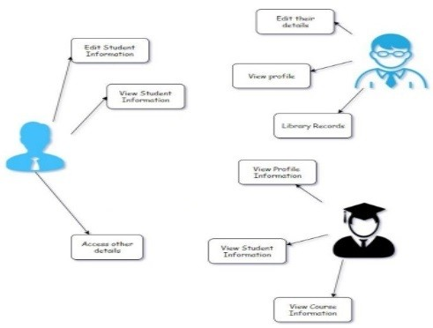

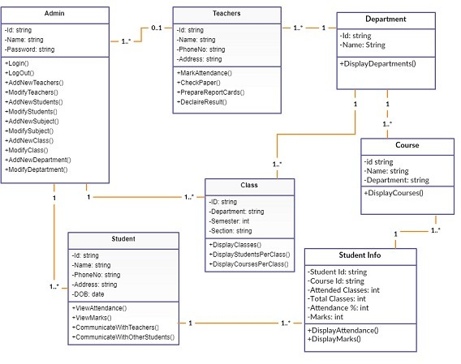**Class Diagram**

Class diagram of college ERP

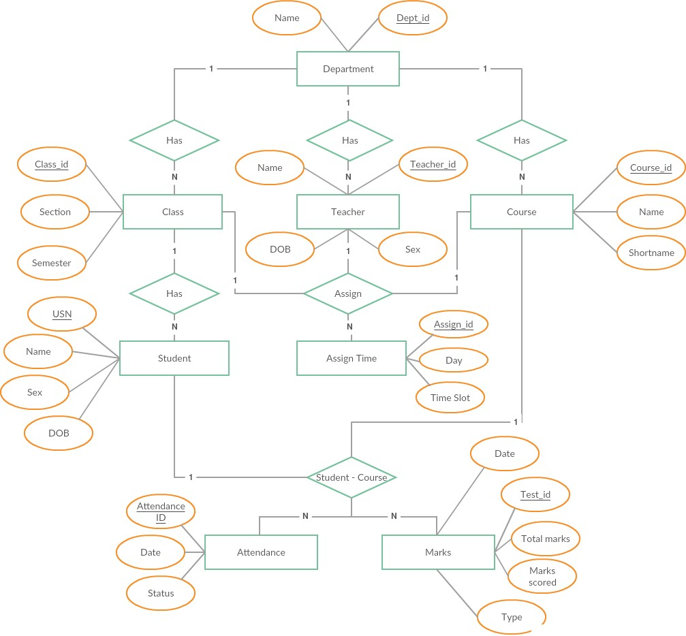**ER - Diagram**

Entity Relationship diagram of college ERP

**References**

1. Elmasri and Navathe: Fundamentals of Database Systems, 7th Edition, Pearson

Education, 2016.

2. Ian Sommerville: Software Engineering, 10th edition, Person Education Ltd, 2015.

3. Roger S Pressman: Software Engineering- A Practitioners approach,8th edition,

McGraw-Hill Publication, 2015.

4. https://en.wikipedia.org/wiki/Requirements-engineering

5. https://web.cs.dal.ca/ hawkey/3130/srs-template-ieee.doc

6. http://www.ntu.edu.sg/home/cfcavallaro/Reports/Report%20writing.htmTop

7. https://en.wikipedia.org/wiki/Class diagram

8. https://www.djangoproject.com/

9. https://getbootstrap.com/

10. https://www.tutorialspoint.com/

11. https://creately.com/

12. https://www.overleaf.com/project